Name: | ___________________________________________ |  |  |  | Date:__________
 | Maths Specialist Unit 2, Investigation 3 – 2015  Trig Graphs and Functions – Validation
Important Information:
Although the take-home component is not worth any marks, it is essential in preparation for the in-class component. Knowledge and skills gained will be extended in the in-class validation component. This in-class validation will be completed under test conditions on the day in which this take-home component is due. The take-home component may be used when completing the in-class component. Contact may be made to parent(s) if the take-home component is not available for submission (at the start of the lesson).
Date out: |  | Week ____ Date __________ | Date Due: | Week ____ Date _________
Take home component weighting: |  | 0% of the year | In-class component weighting: | % of the year.
AIM: In this assessment, you will be investigating the language and Trig Graphs and Functions

- [5 marks]

For y = a cos b(x + c), state how each of the following affects the graph:

- ‘a’ affects the graph by ______________________________________

- ‘b’ affects the graph by ______________________________________

- ‘c’ affects the graph by ______________________________________

- Sate the range of the graph: _________________________________

- [15 marks]

Sketch graphs of each of the following for {x: 0 ≤ x ≤ 2л} stating the amplitude and period of each.

  - f(x) = 3 cos 4x

Amplitude = ________

Period = ________
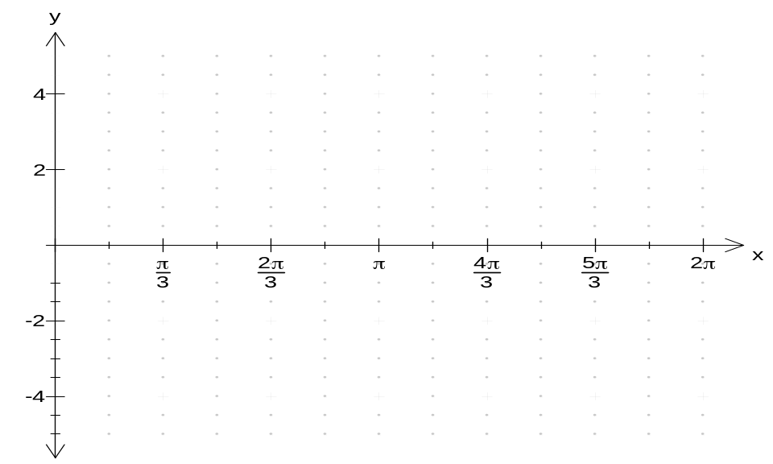

  - f(x) = 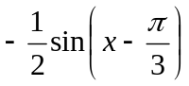

Amplitude = _______

Period = _______

  - f(x) = 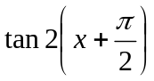

Amplitude = _______

Period = _______

- [12 marks]

State the amplitude, period and give the equation of each of the following graphs.

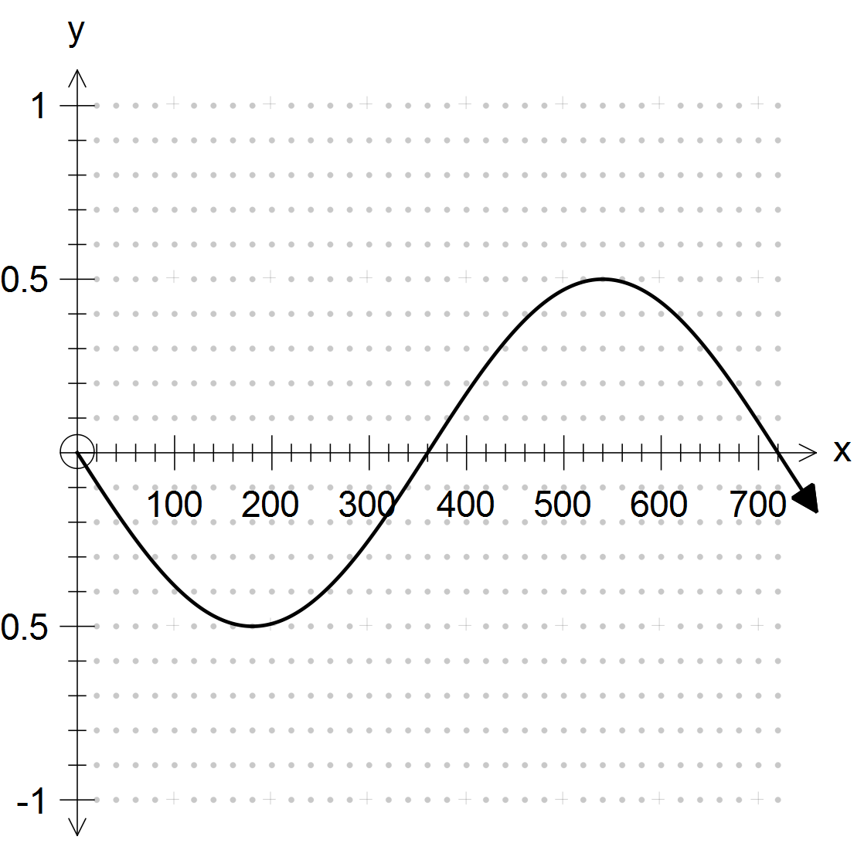

Amplitude: ______ Period: ______

Equation: ____________________________

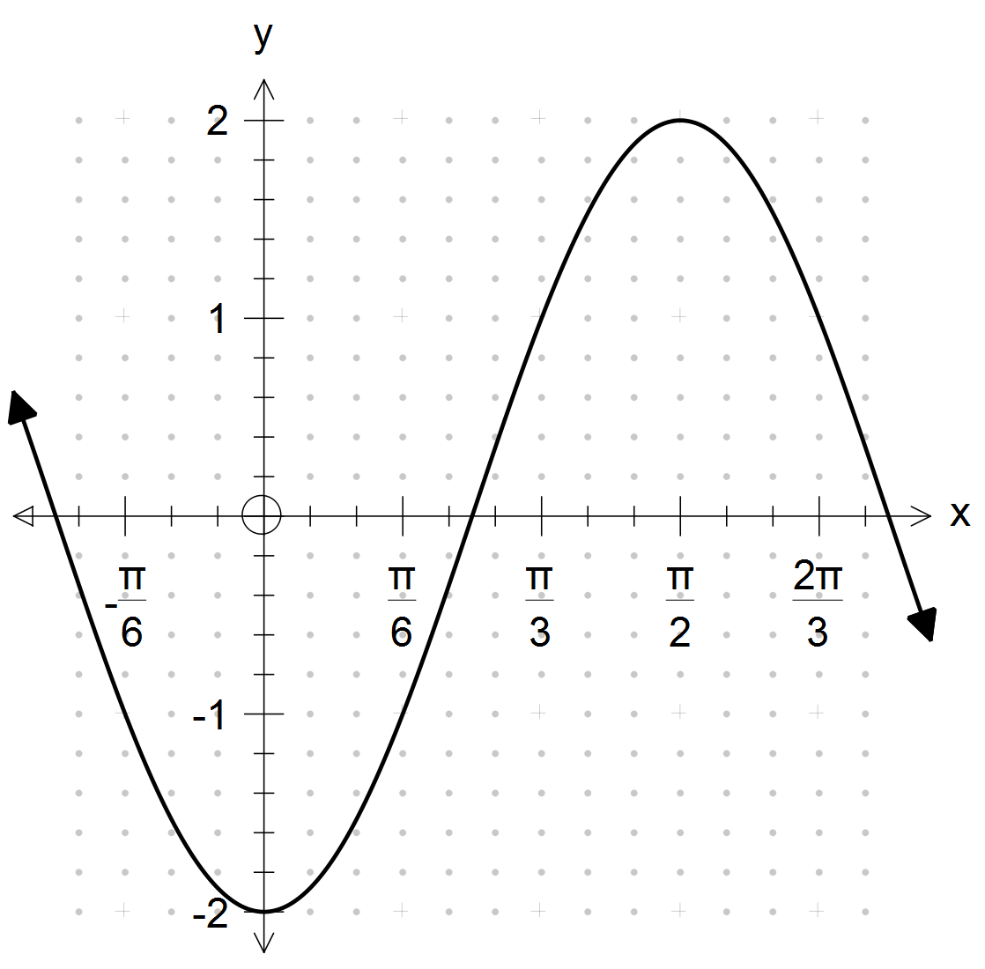

Amplitude: ______ Period: ______

Equation: ____________________________

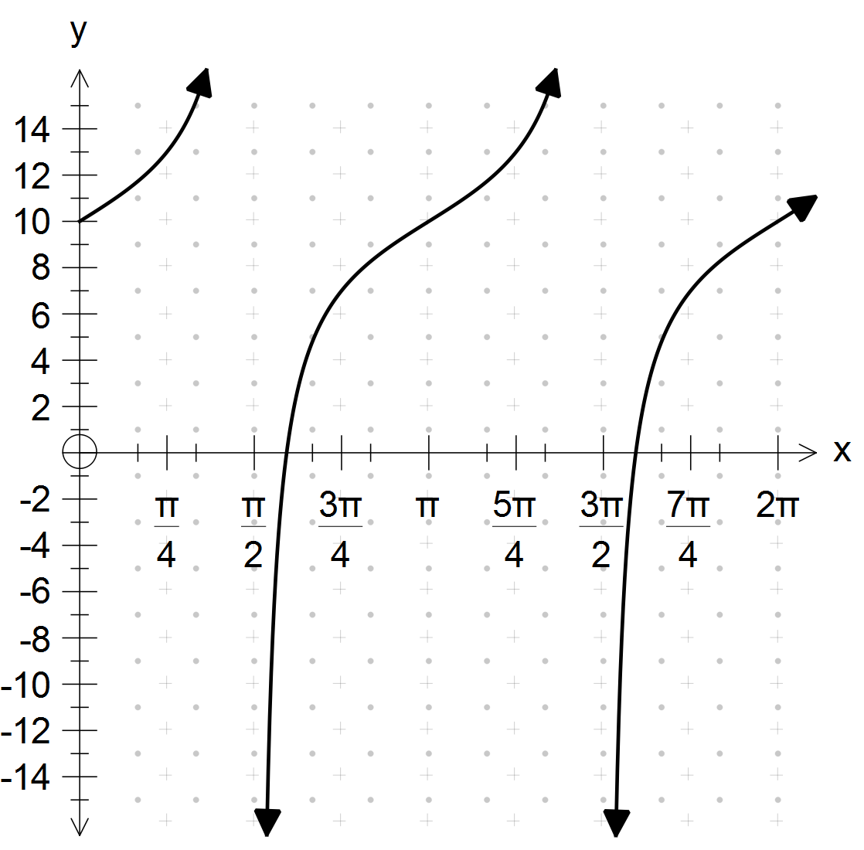

Amplitude: ______ Period: ______

Equation: ____________________________

- [8 marks]

Using degrees on the x axis, neatly sketch one completed cycle (period) of the following, showing clearly the horizontal and vertical scales.

(a) 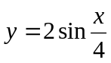

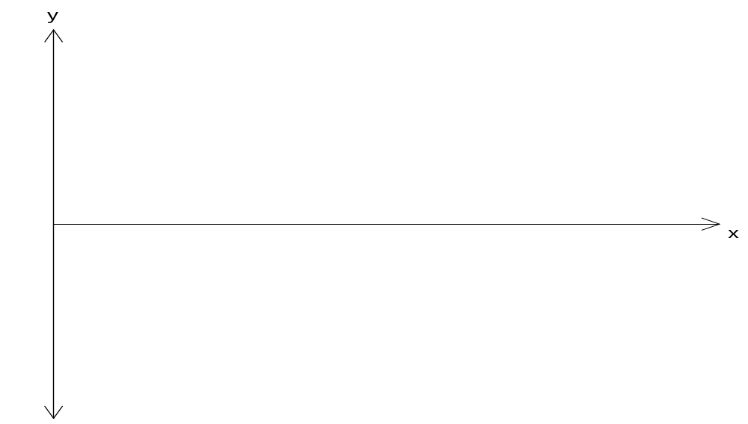

(b) 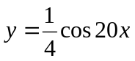

END OF VALIDATION

